User Manual

1. Introduction
   1. Purpose

Welcome to “Traffic Tools”, a powerful tool designed to analyze traffic data along with the penalty information in New South Wales. This user manual will guide you through the application’s features and help you make the most of it.

* 1. Audience

This manual is intended for users who want to understand and utilize the “Traffic Tools” application effectively.

* 1. Scope

This manual covers the installation, usage, and troubleshooting of “Traffic Tools”.

1. Getting Started
   1. System Requirements

Before start using “Traffic Analyze”, ensure that your system meets the following requirements:

* Operating System: Python

1. Dashboard
   1. Overview

The “Traffic Tools” dashboard provides a comprehensive overview of the traffic data and penalty information.

* 1. Navigation

To navigate through the application, utilize the menu at the top of the interface. Here are the main sections you can access:

* Overall Report: Explore a summary of traffic and penalty data.
* Chart Distribution: Visualize data using various chart types to gain insights.
* Cases Captured: Retrieve cases captured by cameras and radar systems.
* Cases Analyze: Dive deeper into the analysis of traffic cases.
* Financial Analysis: Gain insights into financial aspects related to penalties.

1. Reporting
   1. Overall Report

The “Overall Report” section provides a consolidated view of the traffic and penalty data. It includes key metrics, trends, and summaries that give you a quick understanding of the data.

* 1. Chart Distribution

“Chart Distribution” allows you to visualize the data. You can customize the visualizations to highlight specific aspects of the data, making it easier to identify trends and patterns.

* 1. Cases Captured

In this section, you can retrieve cases captured by cameras and radar systems. You can filter and search for specific cases based on offense descriptions and other criteria.

1. Analyzing
   1. Cases Analyze

The “Cases Analyze” feature enables you to perform in-depth analysis of traffic cases. You can explore trends over time, examine offense codes, and extract valuable insights to inform decision making.

* 1. Financial Analysis

“Financial Analysis” provides a detailed breakdown of the revenue generated from penalties. It highlights which offenses typically result in the highest penalties, aiding in financial planning and resource allocation.

1. Appendix

The following illustrations will explain the steps for utilizing the “Traffic Tools” application.

* 1. Overall Report

The initial step requires users to select “Overall Report” from the top navigation bar (1), followed by entering the desired time frame (2,3), and subsequently, clicking the “Submit” button (4).

(Before submitting)

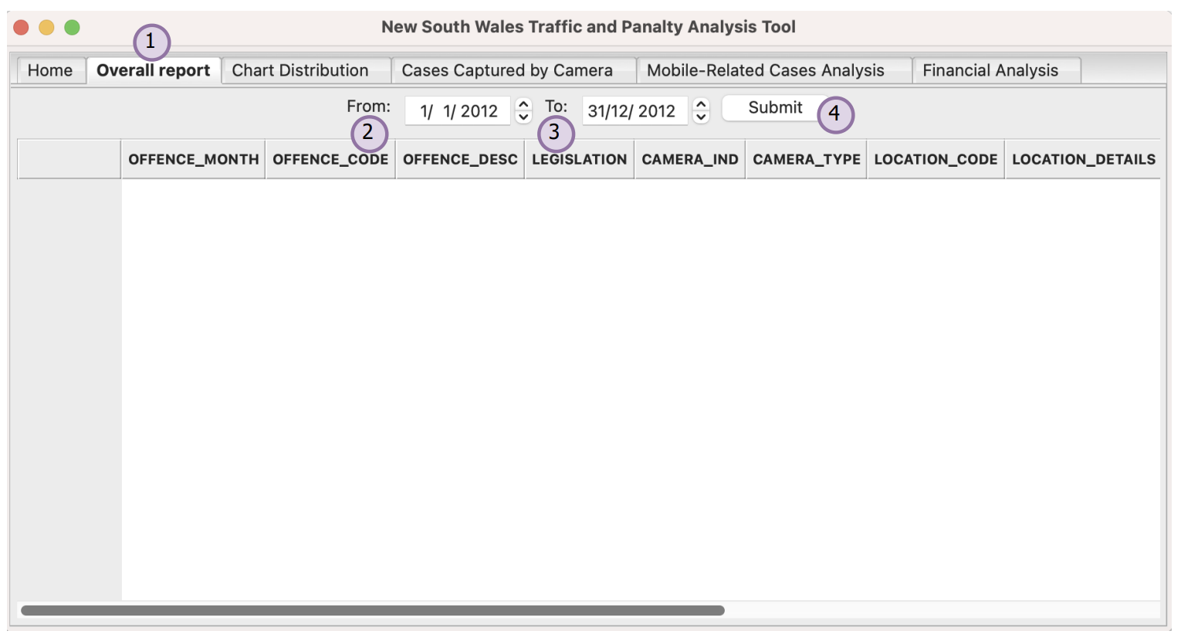

(After submitting)

* 1. Chart Distribution

The initial step requires users to select “Chart Distribution” from the top navigation bar (1), followed by entering the desired time frame (2,3), and subsequently, clicking the “Submit” button (4).

(Before submitting)

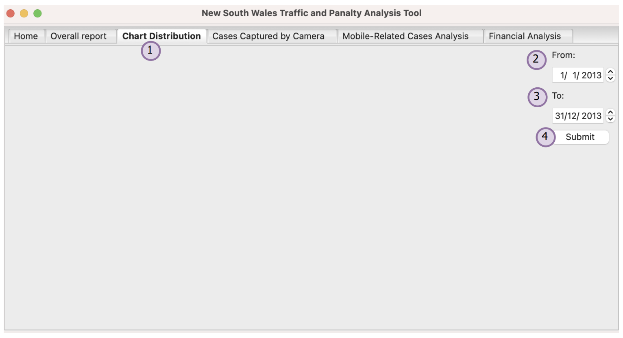

(After submitting)

* 1. Cases Captured

The initial step requires users to select “Cases Captured by Camera” from the top navigation bar (1), followed by entering the desired time frame (2,3). Next, users should check the designated checkbox (4), input the relevant description (5) and finally, clicking the “Submit” button (6).

(Before submitting)

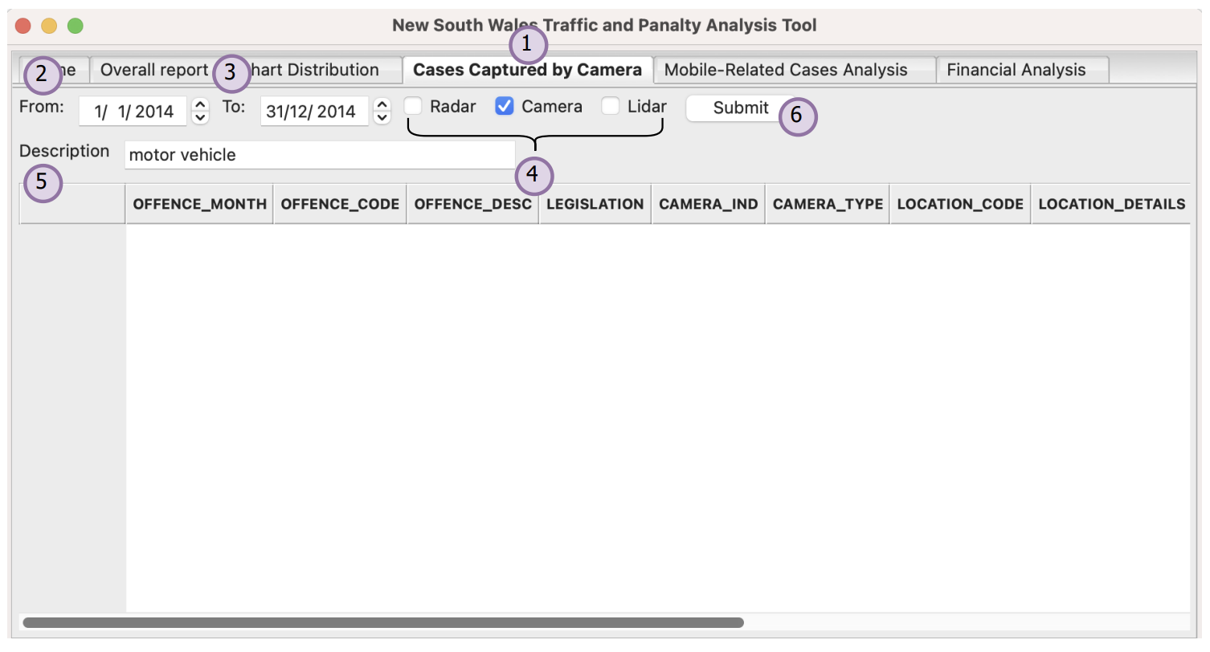

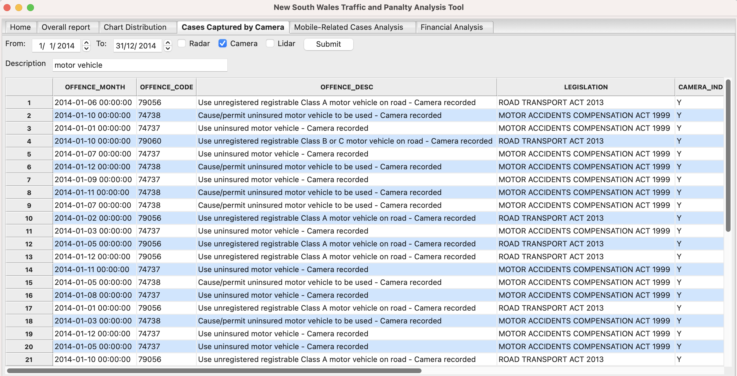(After submitting)

* 1. Case Analyze

The initial step requires users to select “Mobile-Related Cases Analysis” from the top navigation bar (1), followed by choosing the offence codes from the drop-down menu (2). Next, users should enter the desired time (3,4), and finally, clicking the “Plot” button (5).

(Before plotting)

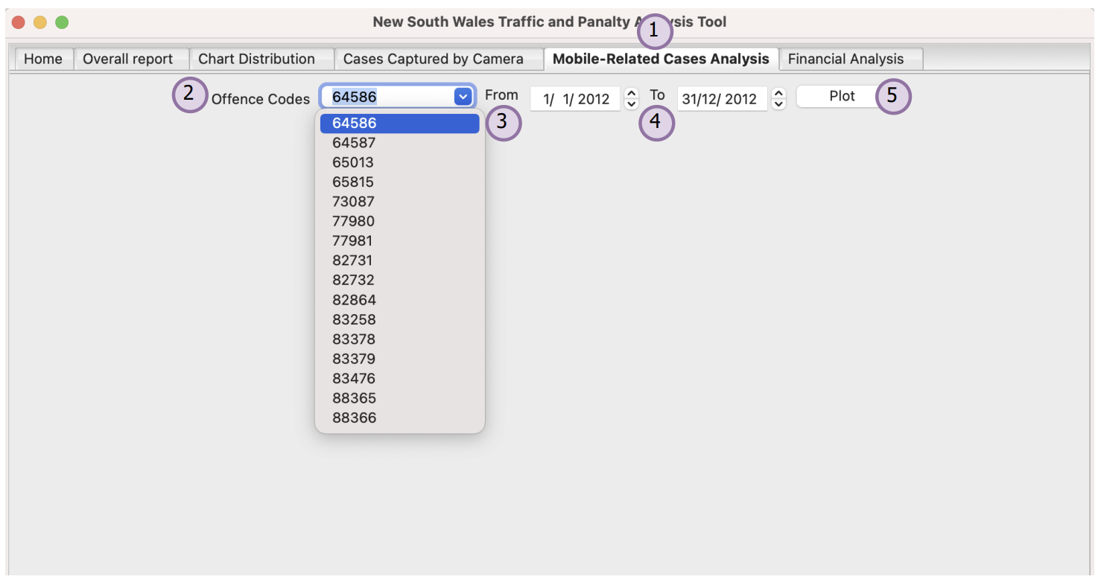

(After plotting)

* 1. Financial Analysis

The initial step requires users to select “Financial Analysis” from the top navigation bar (1), followed by entering the desired time (2,3). Next, users should choose the categories from the drop-down menu (4), and conclude the action by clicking the “Submit” button (5).

(Before submitting)

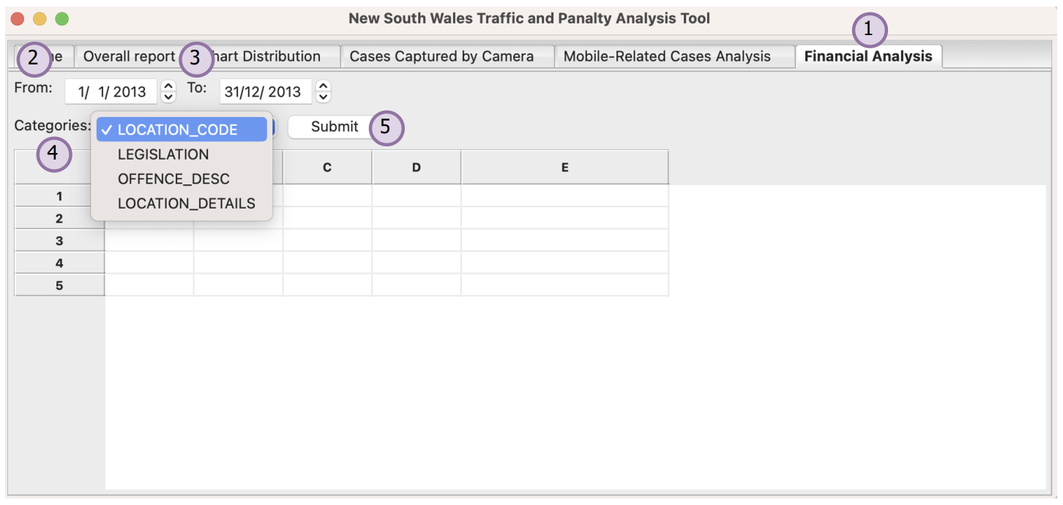

(After submitting)

